| ***Hello World RESTful Web Service*** |
| --- |

Add spring boot starters to the pom.xml dependencies. Then create a new package “controller” and create a new class named “HelloWorldController” under it.

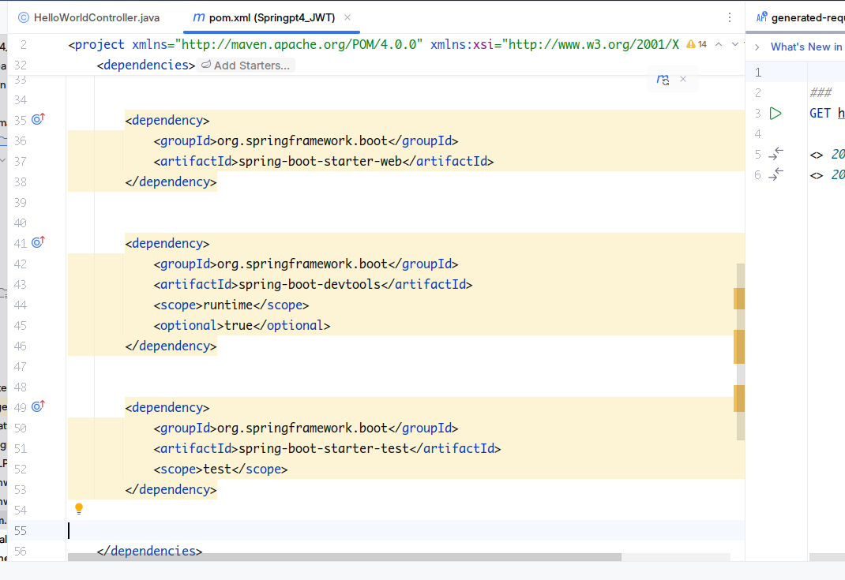

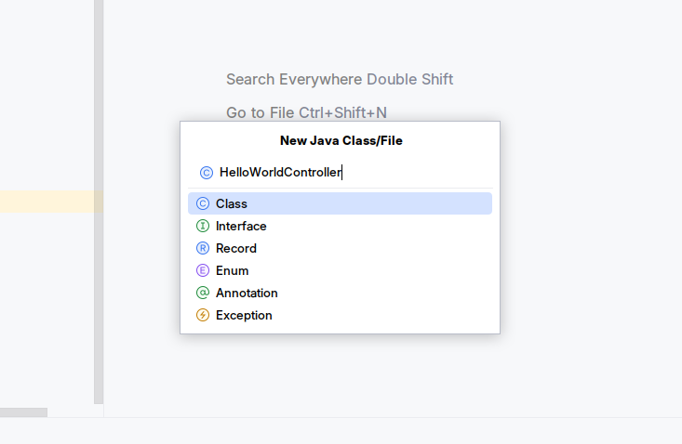

Add @RestController annotation to let spring know that its a controller.

Add methods for mapping to a specific uri.

Test the uri via appropriate http method.

